ABSENTEE BALLOT REQUEST FOR Tribal Run-off Election - July 10, 2021
CHITIMACHA ELECTION BOARD
CHITIMACHA
TRIBE OF LOUISIANA

Complete this form and submit it to the Election Office if you wish to vote by absentee ballot in the July 10, 2021 Run-off Election. This completed form must be mailed, faxed, emailed or personally delivered to the Election Office as indicated at the bottom of this form.
- Please list your name, mailing address and phone number here:

FULL NAME (FIRST, MIDDLE, LAST)

STREET ADDRESS / P.O. BOX CITY STATE ZIP

PHONE NUMBER
- Please clearly print your full name. Then sign and date this absentee ballot request certification statement.
I, _____________________________________ hereby certify that I am a member of the Chitimacha Tribe of Louisiana and that I am a registered voter with the Tribe. I understand that should I decide to vote at the polling place on Election Day, I may do so only if I bring my absentee ballot(s) with me to exchange for a polling place ballot(s). Please mail me an absentee ballot so I can vote by mail in the Run-off Election to be held on July 10, 2021.
Signature:____________________________________ Date:_________________
You may return this Request by mail, email, fax, or hand delivery to the Election Board Office. When returning your Absentee Ballot Request Form you must ensure that you have allowed enough time to receive and return the absentee ballot. In order to receive an absentee ballot directly at the Election Board Office, you must present this completed form and a copy of your photo identification.
Return this form by mail to:
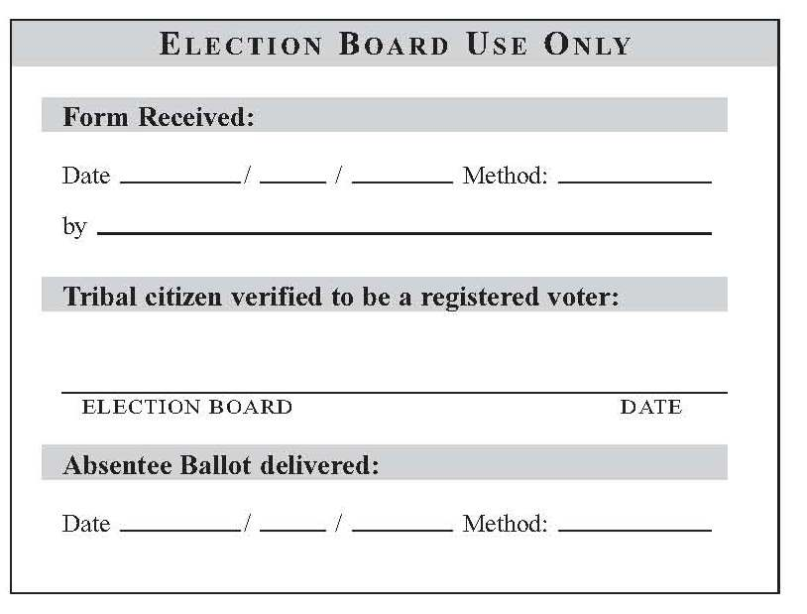
Chitimacha Election Board
P. O. Box 661
Charenton, LA 70523
OR
Return this form by hand delivery to:
Chitimacha Election Board Office
155 Chitimacha Loop
Charenton, LA 70523
OR
Fax to: (337) 923-6848
OR
Email to: Election@chitimacha.gov

